Cyber Security Internship Project Report
📋 Project Overview
- Company: CodeAlpha
- Domain: Cyber Security
- Project Name: Basic Network Sniffer
- Language: Python
- Primary Library: Scapy

1. Source Code Implementation
The sniffer utilizes raw sockets via the scapy library to monitor network interfaces, dissect IP headers, determine packet protocols (TCP/UDP), and extract raw payloads.
python
from scapy.all import sniff, IP, TCP, UDP
def packet_callback(packet):
if IP in packet:
src_ip = packet[IP].src
dst_ip = packet[IP].dst
proto = packet[IP].proto
proto_name = "TCP" if proto == 6 else "UDP" if proto == 17 else "Other"
print(f"\n[+] New Packet Captured:")
print(f" Source IP : {src_ip}")
print(f" Destination IP : {dst_ip}")
print(f" Protocol : {proto_name} ({proto})")
if packet.haslayer(TCP) and packet[TCP].payload:
print(f" Payload Summary: {bytes(packet[TCP].payload)[:50]}")
elif packet.haslayer(UDP) and packet[UDP].payload:
print(f" Payload Summary: {bytes(packet[UDP].payload)[:50]}")
def main():
print("--- Starting Basic Network Sniffer ---")
print("Listening for network traffic... Press Ctrl+C to stop.")
sniff(prn=packet_callback, store=0)
if __name__ == "__main__":
main()

2. Visual Proof & Execution
Environment Execution
To execute packet capturing, administrative privileges are invoked via the terminal interface.
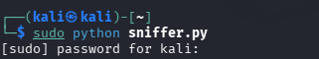
Packet Capture Output
The tool dynamically intercepts network flows, outputting formatted addresses and payload data chunks
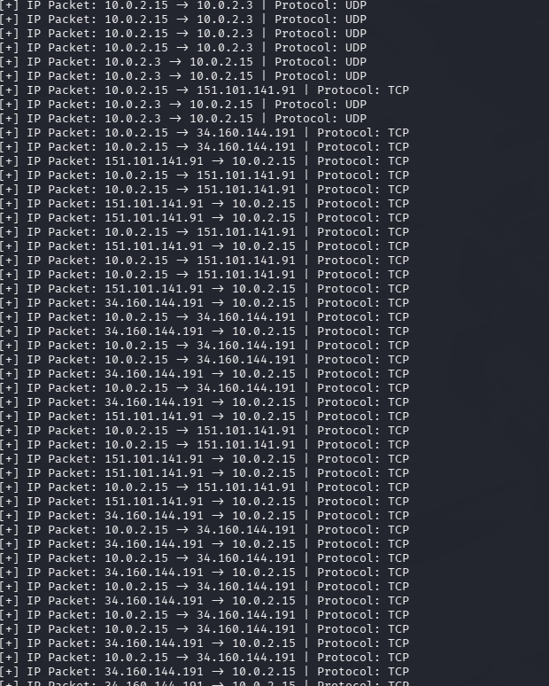.

3. Repository Architecture
The project structure conforms exactly to the specifications provided in the CodeAlpha documentation.
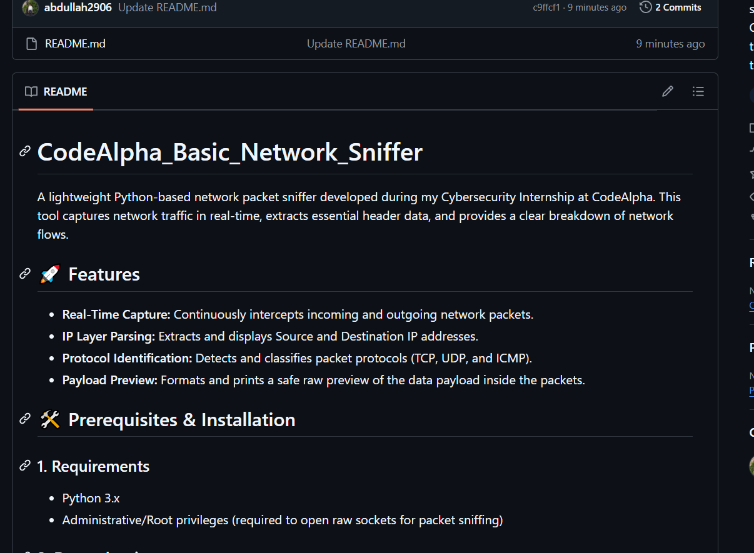

4. Security & Compliance Disclaimer
This application is constructed strictly for educational benchmarks and internal evaluation during the CodeAlpha Internship framework. Packet analysis outside controlled sandboxes or without prior authorization violates standard compliance policies and structural legislation.

